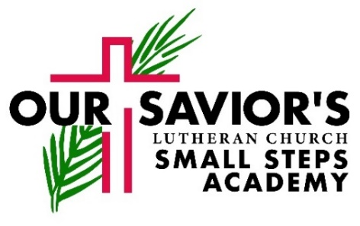
2020-2021
School Calendar

August
15 Parent Orientation
17 FIRST DAY OF SCHOOL
31-2 School Picture Days
September
7 Labor Day – CENTER CLOSED
11 Grandparents’ Day / School Spirit Day – wear your school shirts
21 Volusia Student Holiday-Care by request
26 Port Orange Family Days Parade – wear school shirts/walk with Owl mascot
October
5-9 Fire Safety Week w/Fire Truck Visit, TBA
9 School Spirit Day–wear your school shirts
11 VPK Classes sing in church, 9:30a
12-16 Scholastic Book Fair, Fellowship Hall
13 Book Fair VPK Skit Night, 6:30p in church
19 Volusia Student Holiday-Care by request
30 Pumpkin class parties-bring a costume
November
6 Bike Day – Wear your school shirts
11 Veteran’s Day – CENTER CLOSED
20 Class parties for Thanksgiving
23-27 VPK NO SCHOOL DAY - Thanksgiving Break Begins-Care by request
25-27 Thanksgiving Days (3) – CENTER CLOSED
30 Classes resume
December
13 VPK & 3-Yr-Old’s Christmas Service in church, 9:30a
17 Christmas class parties
18 VPK NO SCHOOL DAYS remainder of 2020
Volusia Student Holidays-Care by request
24 Christmas / New Year’s – CENTER CLOSED
(reopens January 4th)
January
4 Small Steps Academy reopens for childcare
Volusia Student Holiday-Care by request
5 VPK Classes Resume
8 School Spirit Day–wear your school shirts
15 VPK Registration open internally 2021-2022
18 ML King Day - CENTER CLOSED

February
5 School Spirit Day – wear your school shirts
8 VPK Registration open to community
12 Valentine class parties
15 President’s Day – CENTER CLOSED
28 VPK Classes sing in church, 9:30a
March
1-5 Literacy Week–Dress up days:
Mon-Crazy Hair Day
Tue-Pajama Day
Wed-Storybook Character Day
Thu-Superhero Day
Fri-Inside Out Day
2 Literacy Night (for 3-5 year old children)
9-10 Spring & Graduation Picture Days
12 School Spirit Day – wear your school shirts
19-26 VPK CLOSED for Spring Break-Care by request
29 VPK Classes RESUME
April
2 Good Friday-CENTER CLOSED
8-9 Donuts for Dads
11 3-yr-olds & VPK Classes sing in church,9:30a
May
6-7 Muffins for Moms
14 Water Day / School Spirit Day –
wear your school shirts
31 Memorial Day – CENTER CLOSED
June
3 VPK Graduation Practice
4 Circus Day / LAST DAY OF SCHOOL YEAR
–wear your school shirt
5 Graduation Services
7 SUMMER PROGRAM BEGINS
- Camp (for school-aged and kindergarten-bound children only)
- Ongoing Care (for infants, toddlers, and preschool 3-year old classes)
August
6 LAST DAY OF SUMMER SESSIONS
9-13 SCHOOL CLOSED – Teacher Inservice Week

