Small Steps Academy School Year Plan
2020-2021
In response to COVID-19
School year Plan
2020-2021
In response to COVID-19

Changes to the public health situation over the course of the school year may necessitate changes to this guidance.
INTRODUCTION
We have created this plan to aid in navigating the reestablishment of our school where employees, students, and families feel safe and to reduce the impact of COVID-19 conditions upon returning to Small Steps Academy. The guidelines referenced in this plan are based on guidance from the Centers for Disease Control and Prevention (CDC) and World Health Organization (WHO). Regular updates will be made to this plan based on information provided by the CDC, WHO, and applicable federal, state and local agencies.
GUIDING PRINCIPLES
In order to ensure the continued wellbeing of our employees and students the following guiding principles have been put in place:

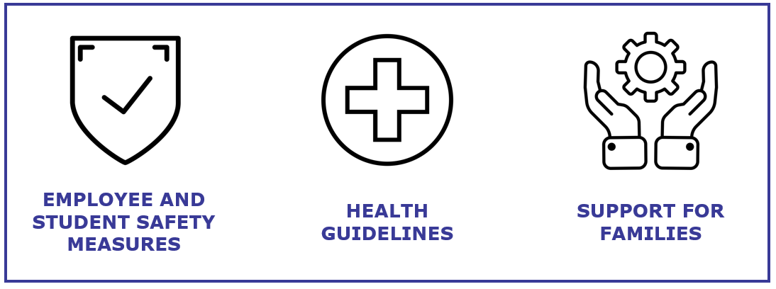

FOUR PRACTICES
Small Steps will:
- Provide notice to parents if a possible exposure occurs.
- Implement practices to prevent the virus from entering the school.
- Respond to a lab-confirmed case in the school at the direction of the local health authorities.
- Continue practices to reduce the likelihood that an outbreak occurs on campus.

EXPOSURE DEFINED
Close contact of less than 6 feet for more than 15 minutes to a person who has tested positive. A person who has COVID-19 symptoms but is unconfirmed is considered a possible exposure.

CLOSE CONTACT (DEFINED)
This document refers to “close contact” with an individual who is lab-confirmed to have COVID-19. Close contact is determined by an appropriate public health agency. For clarity, close contact is defined as:
- Being directly exposed to infectious secretions (e.g., being coughed on while not wearing a mask or face shield); or
- Being within 6 feet for a cumulative duration of 15 minutes, while not wearing a mask or face shield;
If close contact occurs at any time in the last 14 days in which the infected individual was infectious.
Individuals are presumed infectious at least two days prior to symptom onset or, in the case of asymptomatic individuals who are lab-confirmed with COVID-19, two days prior to the confirming lab test.

Small Steps Response Timeline
Please see below for a summary of the phases and timelines.

PHASE | TIMING | ITEMS
PHASE 1 | June | - Implement social distancing protocol and open facilities with limited access/use.
PHASE 2 | July | - Expand use of school based on mandate from Governor DeSantos stating that childcares and summer camps can run without restrictions.
Work Week | August | - Supplies and equipment  - Prepare building for thorough cleaning  - Teacher Training and Development
PHASE 3 | August | - Opening of School  - Based on recommendations and data from CDC, WHO, Florida Governor, and applicable local and state agencies  - Determine what restrictions/guidelines stay in place

VISITOR RESTRICTIONS
Small Steps will limit normal visitation to our campuses at this time. All individuals entering the building will be required to wear face coverings. Individuals proceeding beyond the reception area will be subject to the following guidelines: visitors will be screened, temperatures taken. Visitors and staff will maintain physical distancing.
The safety of our staff and students remains the district’s primary concern. To help prevent the spread of the virus and reduce the risk of exposure to our staff and students, we are conducting a simple screening questionnaire. Participation is important to help us take precautionary measures to protect you and everyone in the building. Small Steps will restrict visits to the school to only those essential to school operations.

EMPLOYEE SCREENING AND PROTOCOLS
To help prevent the spread of COVID-19 and reduce the potential risk of exposure to our employees and students, we will be requiring employees to complete a self-screening which includes staff taking their own temperature; reading and answering a set of questions related to COVID-19 symptoms including:
- Cough
- Shortness of breath or difficulty breathing
- Chills
- Repeated shaking with chills
- Muscle pain
- Headache
- Sore throat
- Loss of taste or smell
- Diarrhea
- Feeling feverish or a measured temperature greater than or equal to 100.0 degrees Fahrenheit
- Known close contact with a person who is lab confirmed to have COVID-19
All screening information will be kept confidential by Human Resource and Small Steps Staff. Teachers and staff must report if they themselves have COVID-19 symptoms or are lab-confirmed with COVID-19, and, if so, they must remain off campus until they meet the criteria for re-entry. Additionally, staff must report if they have had close contact with an individual who is lab-confirmed with COVID-19, and, if so, must remain off campus until the 14-day incubation period has passed.

Student Screening
Parents must ensure they do not send their student to school if the child has COVID19 symptoms or is lab-confirmed with COVID19, and instead wait until the conditions for re-entry have been met. If their child has had close contact with an individual who is lab-confirmed with COVID19, the child should wait until the 14-day incubation period has passed.
BEFORE COMING ONTO CAMPUSES
Daily at the front entrance, Small Steps will screen students to determine if (a) they have the COVID-19 symptoms; or (b) they have had close contact with an individual who is lab-confirmed with COVID-19. Screening is accomplished by posting questions by the door, visual body checks, temperatures taken or asking in person questions. When the parent is dropping off or picking up a student, the screening questions may be asked to the parent. Small Steps Academy is permitted to prevent any individuals who fail the screening criteria from being admitted to the campus until they meet any of the criteria for re-entry to the campus.

HEALTH PROTOCOL
If an employee becomes ill at work or if another person is exhibiting symptoms of COVID19 at work, they may be asked to leave work and go home or to the nearest health center.
Employees returning to work from an approved medical leave should contact HR. You may be asked to submit a healthcare provider’s note before returning to work.

TESTED POSITIVE FOR COVID-19 or SUSPECTED WITH COVID-19
Any individuals who themselves either: (a) are lab-confirmed to have COVID19; or (b) experience the symptoms of COVID19 must stay at home throughout the infection period, and cannot return to campus until the school system screens the individual to determine any of the below conditions for campus re-entry have been met:
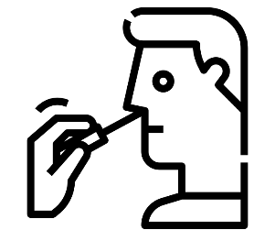
Return to work/school criteria:
- At least 3 days (72 hours) have passed since recovery (no fever without the use of fever-reducing medications); and
- You have improved in respiratory symptoms (cough, shortness of breath, etc); and
- At least 10 days have passed since symptoms first occurred
If the individual has symptoms that could be COVID19 and wants to return to school before completing the above stay at home period, the individual must either (a) obtain a medical professional’s note clearing the individual for return based on an alternative diagnosis or (b) receive a confirmation that they are free of COVID via acute infection tests at an approved COVID 19 testing location.

IDENTIFYING POSSIBLE COVID19 CASES ON CAMPUS
Small Steps will immediately separate any student who shows COVID19 symptoms while at school until the student can be picked up by the parent or guardian.
Small Steps will clean the areas used by the individual who shows COVID19 symptoms while at school (student, teacher, or staff) as soon as feasible.
Students who report feeling feverish should be given an immediate temperature check to determine if they are symptomatic for COVID19.

PRACTICES TO RESPOND TO A LAB CONFIRMED CASE IN THE SCHOOL
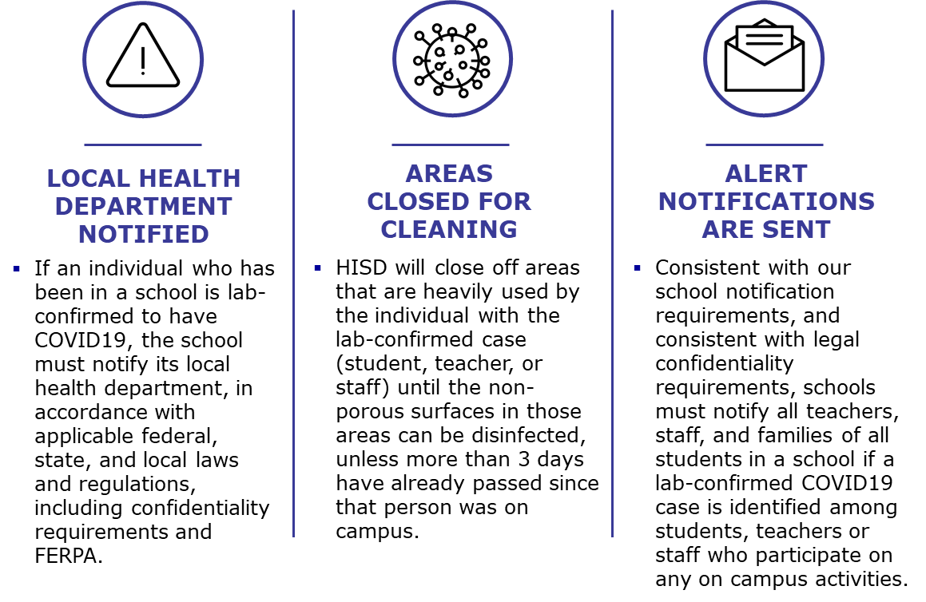

GUIDANCE IF EXPOSED
While we all hope to avoid exposure to illness from COVID19, we need to be prepared for that possibility. If you or someone you have been in contact with has been exposed to the virus, our first concern is for your health and safety and those around you. In this rapidly changing situation, healthcare providers should have the most up-to-date information from the CDC.
Tips for Quarantine from the CDC:
- Quarantine yourself in a specific room away from others in your home
- Contact the following (in order of priority), let them know you have been exposed to COVID19, then follow their instructions.
  - Your healthcare provider
  - HR department
  - Your supervisor
- Our Staff will work with HR to determine appropriate next steps.
- In case of an emergency, call 911 and let them know you have been exposed to COVID19, then follow their instructions.
- Small Steps recommends the student, teacher, staff, or visitor should stay at home through the 14 day incubation period and will not be allowed on campus. If the individual experiences symptoms, they must stay at home until the conditions outlined below have been met.
  - At least 3 days (72 hours) have passed since recovery (no fever without the use of fever-reducing medications); and
  - You have improved in respiratory symptoms (cough, shortness of breath, etc); and
  - At least 10 days have passed since symptoms first occurred

SOCIAL DISTANCING
Social distancing is an effective way to prevent potential infection. Small Steps employees, students, parents, and visitors should practice staying approximately 6 feet away from others and eliminating contact with others.
Traffic Flow – Teachers will help the children to walk in a line in the hallways.

Group Interactions – Teachers will help the children to social distance whenever possible. They will be mindful of their age and what is reasonable to expect given their age.

PERSONAL PROTECTIVE EQUIPMENT (PPE)
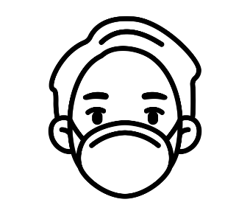
In order to minimize exposure to COVID-19, PPE may be needed to prevent certain exposures. PPE can include:
Masks: Face masks are an important part of employee protection, as well as personal hygiene, social distancing, and frequent cleaning efforts. Schools staff are encouraged to wear masks but are not required to do so. At this time Port Orange is under a proclamation not a mandate.

For students at Small Steps, the determination of whether to wear a mask is up to the student’s parent or guardian. It is not developmentally appropriate for students in kindergarten and below to wear masks.
It is not considered developmentally appropriate for students 4 and under to wear masks according to TEA.
Hand wash: Please remember to wash your hands properly as it is the number-one defense against any virus.

In addition to using PPE, our staff remember to:
- Wash their hands often with soap and water for at least 20 seconds. Use hand sanitizer with at least 60% alcohol if soap and water are not available
- Avoid touching their eyes, nose, and mouth
- Cover their mouth and nose with a tissue when they cough or sneeze or use the inside of their elbow

CLASSROOM CLEANING PROCEDURES
Small Steps staff will use the signage provided to indicate if a room is closed for sanitizing and disinfecting. All teachers and students are asked not to visit the classroom Until it has been properly sanitized. Employees are required to disinfect their own personal classrooms throughout the day, giving special attention to commonly touched surfaces. They complete daily cleaning checklists. The Small Steps Janitor cleans the entire campus once a day.

SHARED WORKSPACES FOR TEACHERS
Employees are encouraged to disinfect their own workspace multiple times throughout the day, giving special attention to commonly touched surfaces. Small Steps has alcohol-based hand sanitizers throughout the workplace and in common areas. Cleaning sprays and wipes are also available to clean and disinfect frequently touched objects and surfaces such as telephones and keyboards.
Please note that proper equipment such as acceptable disinfectant and PPE should be used when cleaning individual workspaces.
There will be limited access to certain workspaces to reduce exposure to risks and ensure employee safety. Workspace usage is as follows:
- Capacity – Small Steps will be monitoring the number of employees in the offices while the risk of infection exists and begins to diminish.
- Conference Rooms –capacity limits will be placed on conference room doors.
- Breakrooms or Teacher Lounge/Multipurpose Room –These spaces will be monitored for occupancy.
- Copy Room – The Copy machine was placed in the Director’s office so employees can make copies while maintaining their social distance.

FACILITIES CLEANING
The safety of our employees and students is our first priority. Upon reopening, our schools have been completely cleaned and disinfected and we will continue to adhere to all necessary safety precautions. In addition to the deep clean off the facility and school before employees and students return, the cleaning steps outlined below are to be taken in the classrooms. to protect employees and reduce the risk of spread of infection. We will require employees to maintain this safety standard by continuously cleaning and disinfecting based on the frequency stated below.

GENERAL DISINFECTION MEASURES
Category | Area | Frequency
WORKSPACES | Classrooms, Offices | At the end of each use/day
APPLIANCES | Refrigerators, Microwaves, Coffee Machines | Daily
ELECTRONIC EQUIPMENT | Copier machines, Shared computer monitors, TV’s, Telephones, keyboards | At the end of each use/day and/or between use
GENERAL USED OBJECTS | Handles, light switches, sinks, restrooms | Up to 4 times a day
Commonly touched surfaces | Cubbies, tables, chairs and toys | Up to 4 times a day
COMMON AREAS | Fellowship Hall, Lobby, Resource Room and Hallways | At the end of each use/day; between groups

The goal is to establish best sanitation practices to use throughout the school year. The site will be 100% disinfected prior to opening on August 17th.

GENERAL DISINFECTION MEASURES PROTOCOL
General measures should be followed regularly. Small Steps will institute more frequent cleaning practices, including additional cleaning by janitorial staff, as well as provide the opportunity for children to clean their own spaces before and after they are used, in ways that are safe and developmentally appropriate.

DEEP CLEANING AND DISINFECTION PROTOCOL
Deep cleaning is triggered when an active employee or student is identified as positive for COVID19 based on testing. Deep cleaning should be performed as soon as the confirmation of a positive test, as practical. While the scope of deep cleaning is presumed to be the full site, sites may reduce the footprint to be deep cleaned if there is sufficient rationale to do so, and they gain consensus of the superintendent and the COVID19 Crisis Team. Notwithstanding the above, if an active employee is confirmed to have a COVID19 positive test, in lieu of performing deep cleaning, School Board may shut down the site for a period of 72 hours to allow for natural deactivation of the virus, followed by site personnel performing a comprehensive disinfection of all common surfaces.
- Small Steps will close off areas that were heavily used by the individual with the lab-confirmed case (student, teacher, or staff) until the non-porous surfaces in those areas can be disinfected, unless more than 3 days have already passed since that person was on campus.
- Notification: Small Steps will notify all teachers, staff, and families of all students in a school if a lab-confirmed COVID19 case is identified among students, teachers or staff who participate in any on-campus activities.

SIGNAGE
Signage will be placed throughout the offices and school.
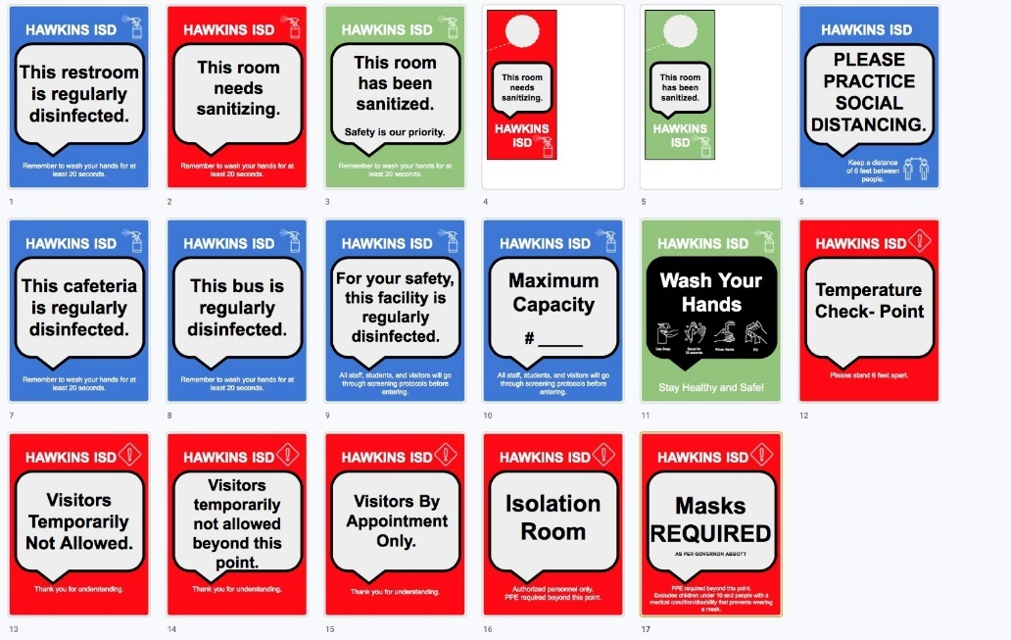

PRACTICES TO MITIGATE THE LIKELIHOOD OF COVID19 SPREAD INSIDE THE SCHOOL
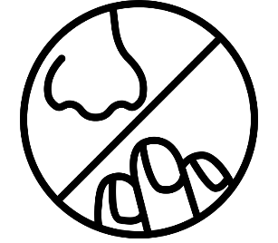
- Small Steps will have hand sanitizer and/or hand washing stations with soap and water in classrooms.
- Students, teachers, staff, and campus visitors will be encouraged to sanitize and/or wash hands frequently.
- Small Steps will strive to provide an adequate supply of soap, disinfection, hand sanitizer, paper towels, and tissues
- Small Steps will strive to provide a supply of gloves and other protective gear
- Touchless thermometers on-site for employee and student screening
- Students, staff, teachers, and visitors should be encouraged to sanitize and/or wash hands frequently. Small Steps encourages supervision of younger students as students engage in handwashing for at least 20 seconds numerous times a day, in addition to washing hands after using the restroom and before and after eating.

STUDENT AND TEACHER GROUPINGS
Where feasible without disrupting the educational experience, Small Steps will encourage students to practice social distancing, however at such a young age handwashing is going to be our best defense.
In classrooms where students are regularly within six feet of one another, Small Steps will plan for more frequent hand washing and/or hand sanitizing and will consider whether increased airflow from the outdoors is possible.

ENTRY AND EXIT
Campuses will plan for entry, exit, and transition procedures that reduce large group gatherings (of students and adults) in close proximity. Students will be entering and exiting from the main lobby doors. Parents are encouraged to wait six feet apart outside the entrance during drop off and dismissal.

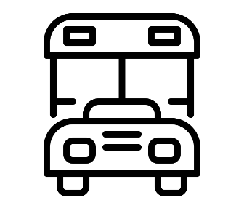
SAFETY SUPPLIES
Small Steps has purchased several safety items:
- Touchless Forehead Thermometers
- Face masks
- Nitrile Powder Free Gloves
- Hand sanitizer

RESTROOM USAGE DURING THE WORKDAY
Establish maximum capacity for the facility that allows for social distancing. Post the maximum capacity sign on the door. Provide supplies for employees to clean up after themselves in staff only restrooms.

SOCIAL-EMOTIONAL WELL-BEING OF STUDENTS AND STAFF
The Small Steps administration encourages parents to visit: wlcfs.com They have developed videos and resources for parents to access. They have online counselors that can work with families to address any well-being needs. Pastor Jeff is also available for on-site counseling to work families that have well-being needs.

STAFF TRAINING
- Pre-Return to School Training - Presented to Staff during our teacher Work Week.
- First Day- On the first day of school, Small Steps will help students learn proper handwashing techniques.
- Cleaning Crew Protocols - Disinfection methods, comprehensive cleaning training
It is very important that all employees understand the safety requirements, protocols and expectations to ensure everyone and their communities stay safe and prevent the spread of the virus.
We will structure the training plan to effectively disseminate information to all teams and audiences.
Content Covered:
- All training topics can be reinforced with signage in the buildings.
- Daily cleaning checklists
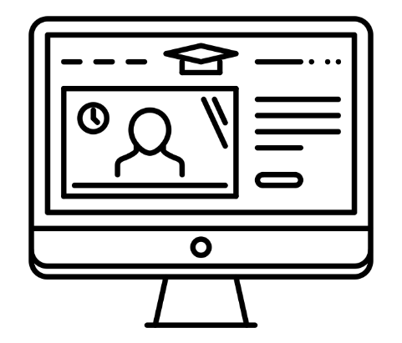
- Response Teams
- Disinfection Measures
- Isolation protocols
- On site health screening
- Daily self-screenings
- Visitors
- Cleaning Crew Protocols

COMMUNICATION METHODS
To stay updated on the most up-to-date information:
- Teachers and parents need to check their email often.
- Visit our school website
- Follow our social media platforms- facebook
- Brightwheel app

PARENT COMMITMENT
Parents will be asked to acknowledge on campus procedures. Small Steps has a release of Liability document that we are asking all parents to sign. Small Steps also asks parents to help reinforce handwashing and personal hygiene skills at home. Visit the CDC’s website for handwashing posters you can print off to have at home.

